**ACTIVITY 1**

**Individual work !**

1. Draw the DOM tree for the HTML code below :

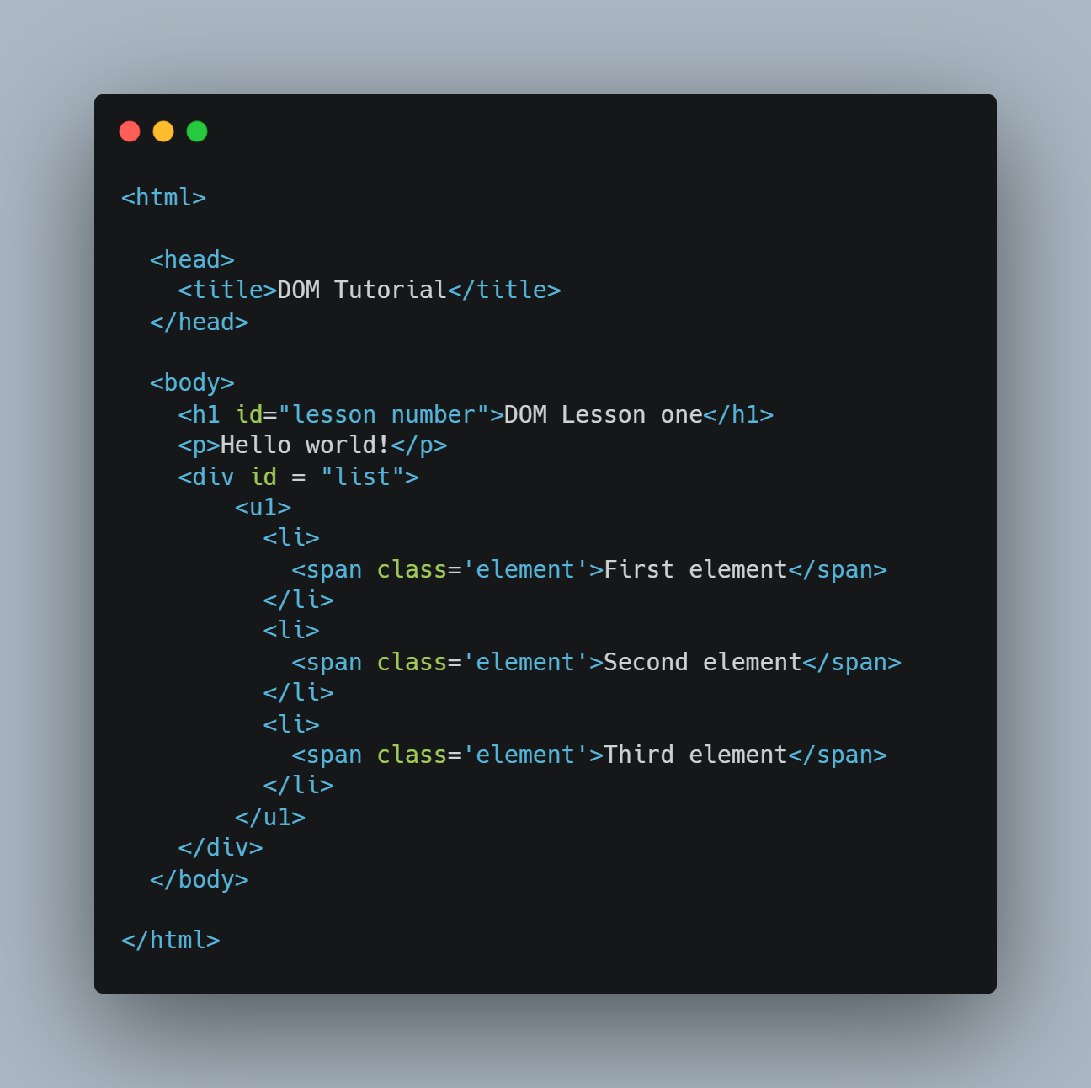

1. **Answer the questions :**

|  |  |
| --- | --- |
| How many **children** does the <h1> node have |  |
| How many **children** does the <head> node have |  |
| How many **siblings** does the first <li> node have |  |
| Who is the **parent** of the second <span> node |  |
| Who is the **parent** of the <u1> node |  |
| Who is the **first child** of the <body> node |  |
| How many **children** does the <body> node have |  |
| How many **siblings** does the <u1> sibling have |  |
| What is the **root** **node** does it have parents |  |